Day 2: Services, Cost, and Scripting

# Understanding how total cost ownership is used in it

Compare two printer (example) to find out the cost

I choose these 2 printer to compare

Inkjet printer and laser printer

Comparison for both printer base on printer price, cartridge price (black&colour), page use in 5 years, maintenance support and estimated total cost

# Cloud computing

Signed up for a free-tier AWS account and launched EC2 instance using Ubuntu Server 22.04. LTS AMI.

Generate SSH ket pair(.pem file) to securely access the VM.

Key pair naming

Configure security group firewall to allow traffic on Port 22 (SSH)

Port 80(HTTP) for web server

Select the firewall security group

Successfully connected

Check the instance for running

Check for ssh client for cloud vm public ip address

Connect and can see the consoled in our webpage

Using our vm to ssh to the cloud machine

Download the reading to my directory

Move into html directory

Insert to index.html

Refresh link and can see the click here link

After click direct to the pdf download earlier

# Bash Coding

Create folder name Labfiles using command mkdir

Create script to test

Copy file and rename it then remove the file

Create another script file name hello_world.sh

Create another script file name system_info.sh and give full access using chmod 777

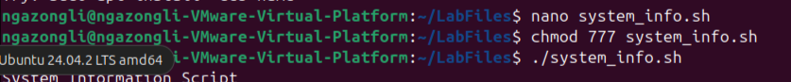

System_info.sh

Run the system_info.sh file using ./

Create a resource_monitor.sh script to monitor CPU, memory and disk usage detail

Output

